**Open Street Maps into Unreal**

In modern game development, achieving high levels of realism has become a powerful goal for developers. Players increasingly demand immersive experiences that include massive environments that mimic real-world areas, prompting game creators to explore innovative techniques for achieving authenticity. One such approach explored in this research is the integration of geospatial data, which provides a wealth of real-world information that can enhance the fidelity of game environments procedurally while saving many hours of labor.

**Figure 1**

*Geospatial Data*

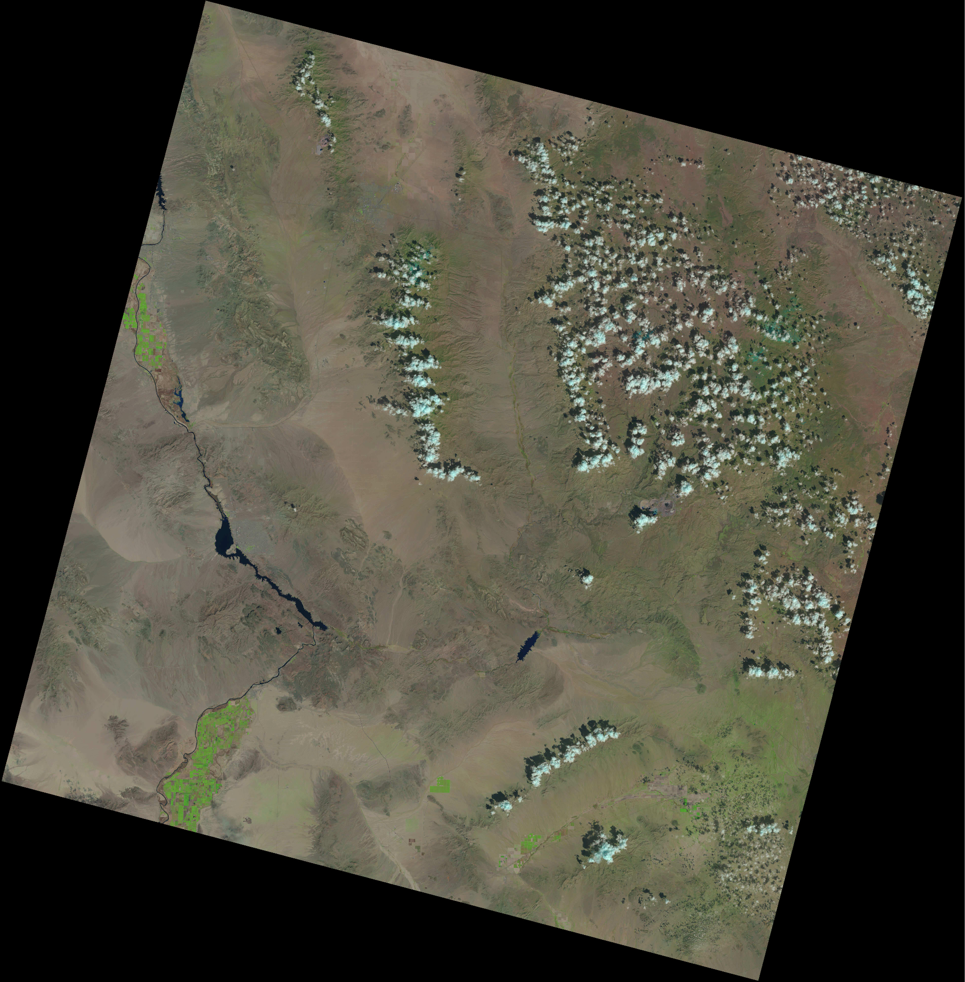

This research explores the process of integrating geospatial data from Open Street Maps (OSM) into Unreal Engine, a leading game development platform renowned for its visual fidelity and flexibility.

Currently, Cesium, a tool for streaming geospatial data within the Unreal Engine, does not support a direct download of the geospatial data it streams to its users. An alternative is to download the Open Street Maps (OSM) data from services like Google and Bing. The OSM data from these services are downloaded in formats such as .geojson, .gpx, .kml, and .osm. These formats typically show as a heightmap that Unreal can translate as a very rough terrain. Platforms such as openstreetmap.org, Earth Explorer, and Overpass Turbo provide means to download OSM data, enabling developers to extract detailed information about terrain, roads, buildings, and other geographic features. These services give the user the ability to draw a square section of the globe and export any data on the buildings contained therein, including shape.

**Figure 2**

*Open Street Maps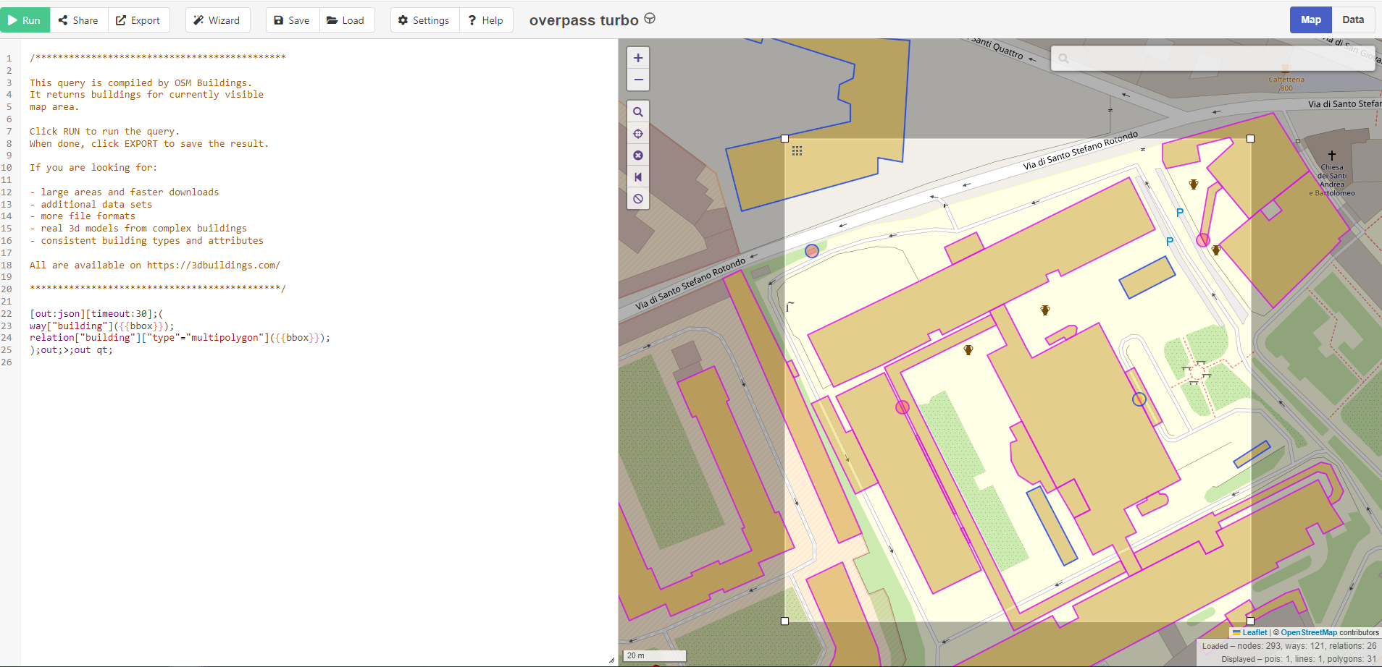*

Plug-ins have also been created for the Unreal Engine for those that are using C++ Unreal projects.

The integration of OSM data into Unreal Engine involves a multi-step process facilitated by specialized tools and software. With Houdini, developers can harness specific tools provided by SideFX to process OSM data and generate 3D models of buildings and road networks.

**Figure 1**

*Houdini Import*

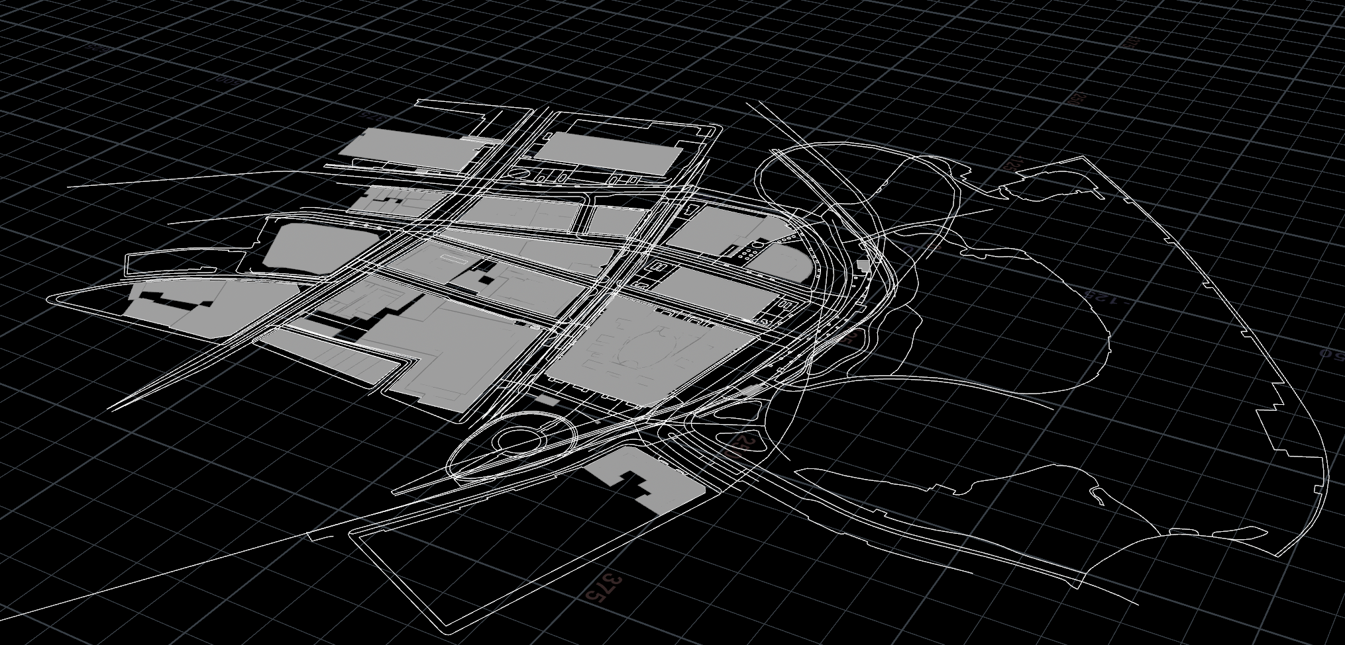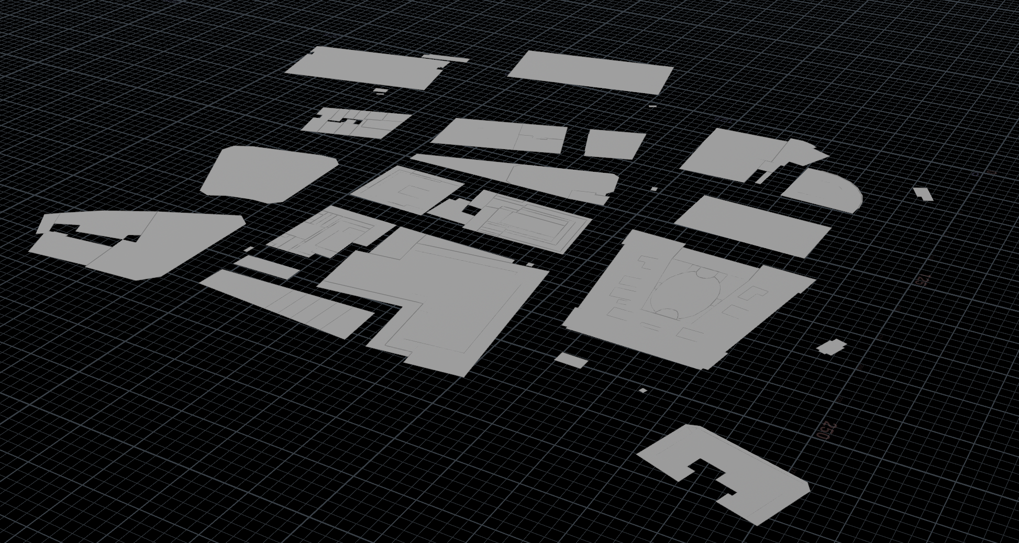

A “Labs OSM Buildings” node is then used to create 3D models in the shape and location of the buildings based on that data. The topology on these generated models will need some retopology to be made game-ready.

**Figure 1**

*Procedural building retopology*

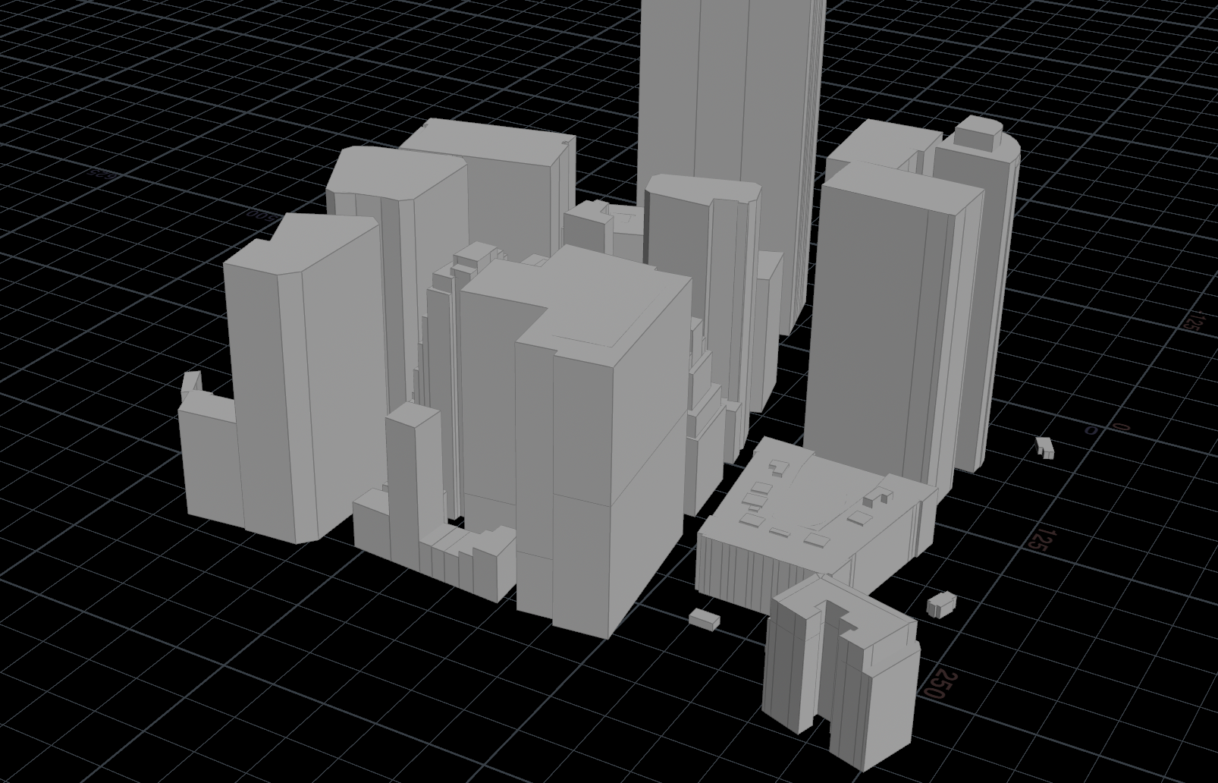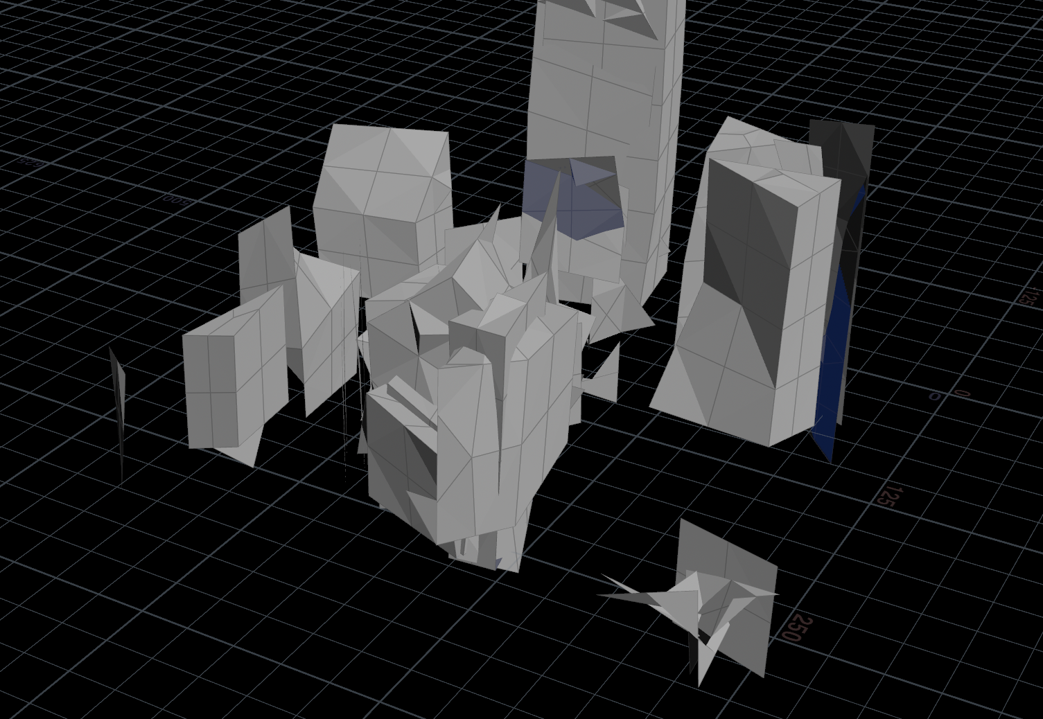

The polyreduce, quadrangulate, bevel, and clean nodes can achieve acceptable models to be exported with a “ROP fbx” node.These models are derived from the data extracted from OSM, enabling developers to recreate real-world structures within the virtual environment. However, additional steps such as retopology are often required to optimize these models for use in real-time applications like games. Once prepared, the models can be exported as .fbx files for integration into Unreal Engine.

**Figure 1**

*Unreal Engine Plug-in*

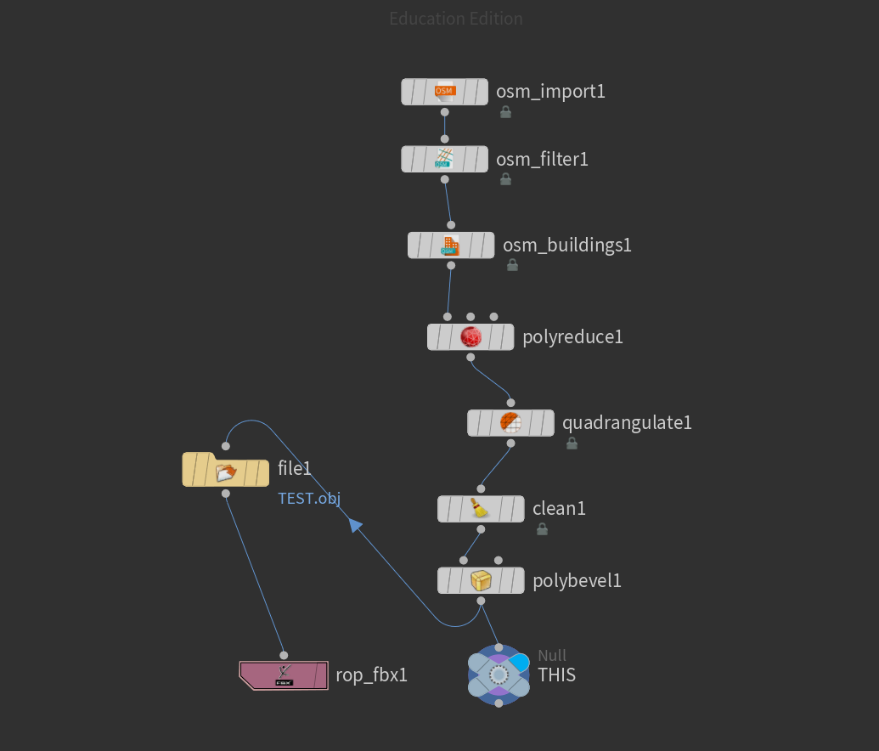

Upon importing the generated models into Unreal Engine, developers gain access to a wide array of tools and features for further refinement and customization. Plugins tailored for C++ Unreal projects streamline the integration process, allowing developers to efficiently incorporate OSM-derived assets into their projects. Once imported, these assets can be manipulated and enhanced using Unreal Engine's robust suite of editing tools. Notably, the integration of Niagara VFX enables developers to apply dynamic visual effects to imported meshes, enhancing the realism and interactivity of the virtual environment.

**Figure 1**

*Unreal Engine Plug-in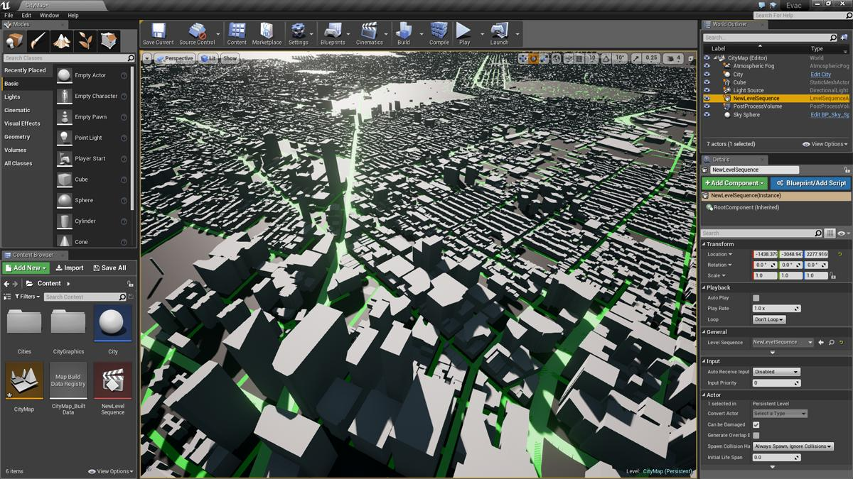*

Note. An example of the use of the Unreal Plug-in output. Image courtesy of NativeRock through the Unreal Engine Forums.

A sprite emitter that uses mesh reproduction can appropriately replace the buildings with sprites when it is activated with a blueprint. This gives the appearance that the buildings on this city skyline have fallen to dust.

**Figure 1**

*Unreal Engine Plug-in*

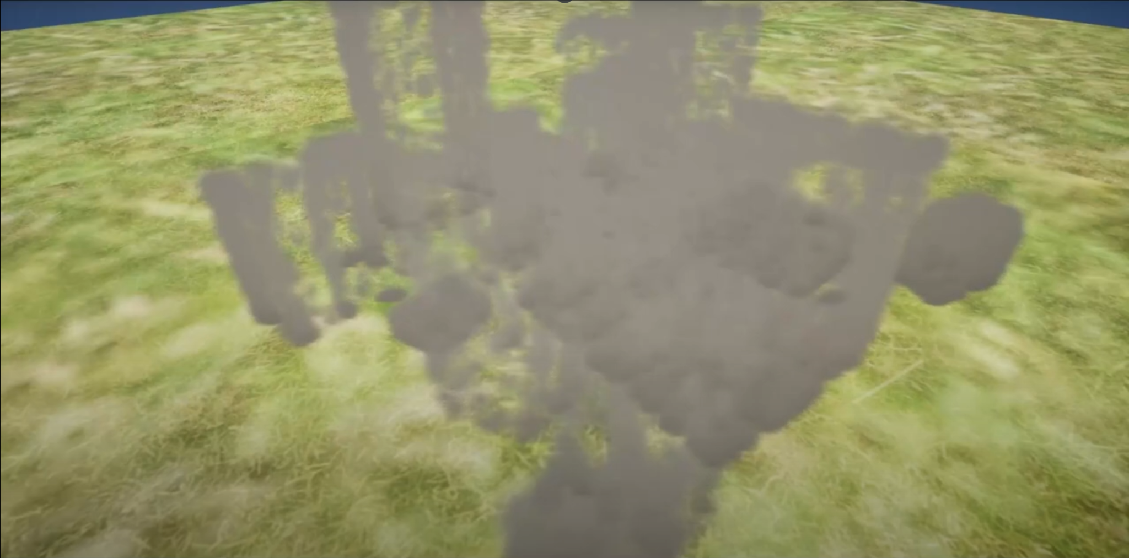

See <https://youtu.be/M2Zv-KJDNgs> for an example. The Unreal Engine’s particle effects system, Niagara, can instantaneously spawn numerous sprites on the skin of objects such as the buildings provided by the OSM data. With some added velocities for gravity and curl noise force, the dust falls away. Aerodynamic drag maintains a smoky aesthetic.

**Figure 1**

*Mesh Reproduction Sprite*

